Occupational/Occupational Performance

Occupational Analysis Paper from OCCT 506 [link]
Child Based Group Care Case Study[link]
Occupation Profile form 530
AT device from OCCT 649
Adult evaluation form from OCCT 645
Occupational Profile form OCCT 651
Fieldwork Information
Final Synthesis

Evidence Based Practice

Quantitative Paper from OCCT 504 [link]
Qualitative Paper OCCT 523[link]
Child-Based Research Review from OCCT 526 [link]
Systematic Review from OCCT 643 [link]
Fieldwork
Final Synthesis

Leadership

Professional Development Plan OCCT 508
YEARS | Personal | Career | Education | Recreational Leisure
1 year | I am more confident in my abilities at school and in my personal relationships. | I successfully completed my level I fieldwork with good marks. While in my fieldwork, I am able to apply many of the OT models to many case studies. I am able to apply these foundational theories, models and frameworks to my fieldwork situation. | I am able to understand theories that would be applicable to older adults. I understand theories that are applicable to many different people groups, but my main focus is older adults. I took the initiative to attend an AOTA conference. | I work out at least 3 days a week at the gym.
3 years | I’ve grown in my abilities to be more sensitive to others and to advocate for others in my community. I am a person that will do the right thing in very hard situations. | I passed the NBCOT test the first time because I was prepared. I now work at a nursing home as an OTR with older adults. I have worked for 7 months after graduating and I am still a member of AOTA. I am practicing as an OTR while applying my knowledge from school to many different life situations. | By now, I have OT friends who are experienced and who I bounce ideas about practicing OT. I am still researching older adults by reading magazines. I continue my education by attending AOTA conferences. I attend training that gives me a step up from others specifically dealing with older adults. | I’ve accomplished a century, which is a bike race in the United States.
5 years | My personal goals are to have close personal relationships with the other OT’s at my work. I work and get along with the entire staff at the nursing home and we are able to work through problems and situations as a team. | My career looks like attending many trainings and attending many conferences dealing with ways of improving the lives of older adults. I continue reading textbooks that are applicable to situations at work. I am familiar with revised frameworks and models. I have memorized the Occupational Therapy Framework. | I am taking several classes that would be applicable to the field to help me be more informed with the changing field. | I work out 4 days a week in the gym.
10years | I am close with my family and live close to them. I love to share my life and impact others by always encouraging them by being a great example. | I am an OTR that is versatile who is very experienced. I am able to work at a variety of settings. I work at a school, a hospital and a nursing home. | I am starting to work on my PHD to continue my education. I am working toward becoming an OT teacher. | I will attempt to climb the highest peak in South America.

Professional Developmental Plan from OCCT 650
A reflection on how these 2 professional development plans have changed
Artifact 1 | Leadership Artifact
Item | I am becoming member of the Geriatric Interest Group.
Why | This is a leadership -based artifact because I will be going out into the community to volunteer my time. We are volunteering to make sure older adults have a better quality of life through various activities. I am taking the initiative to go out and help, listen, advocate by listening to what they need changed!
Importance | This is important to me because I eventually want to work with older adults and want them to be heard. Many people over-look the older population and think how they are, stuck in their ways, bitter at the world, and have nothing good to say. They contribute to our lives and impact us in many different ways, they are a wellspring of great advice, and they encouraging.

Final Synthesis

Social Justice
Artifacts 1 | Social Justice
Item | I pledged to end the use of the r-word. Spread the Word to End the Word, “retarded.” The Special Olympics and an ongoing intent to promote the inclusion and acceptance of people with intellectual disabilities.
Why | By promoting not using the r-word we are advocating for individuals who have intellectual disabilities to make sure they are being treated appropriately. It is excluding people from social groups and not admonishing their talents. It alienates certain people and I am helping to put a stop to this.
Importance | This is important to me because I think individuals who have disabilities need to be encouraged by not using the r-word. It is important to me to not reinforce the stereotypes of people who have intellectual disabilities. It shouldn’t be acceptable and is not acceptable to degrade or insult those who have intellectual disabilities.

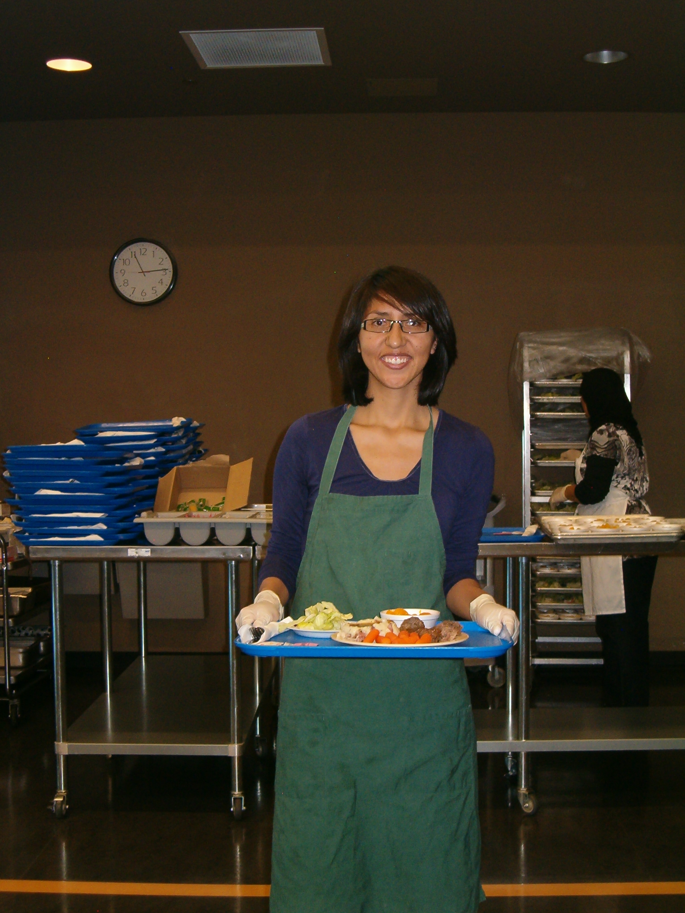
Artifacts 2 | Social Justice
Item | Volunteering at the Heritage Senior Center and serving food to seniors for lunch.
Why | I wanted to serve seniors and get to know them on a more personal level. I enjoy visiting seniors.
Importance | This is important to me because I like to serve seniors.

